Learning Activity Report Week 2: Log Parsing

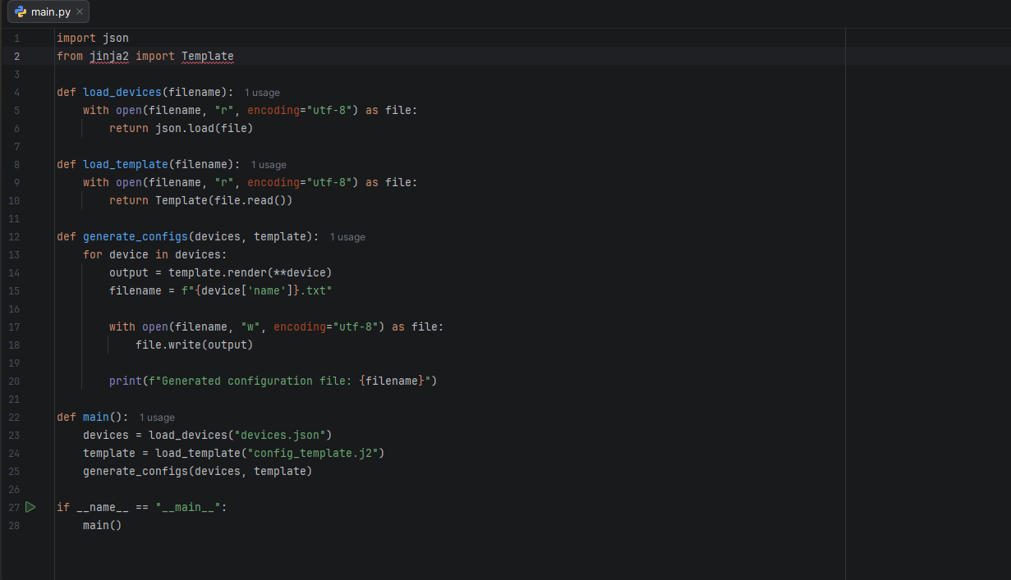
Python Script:

Jinja2 Template
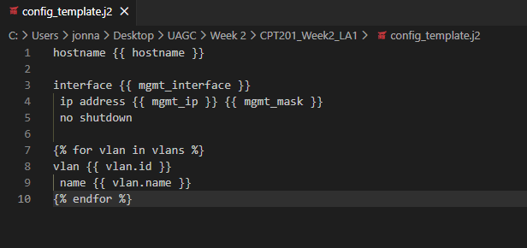

Script Output:
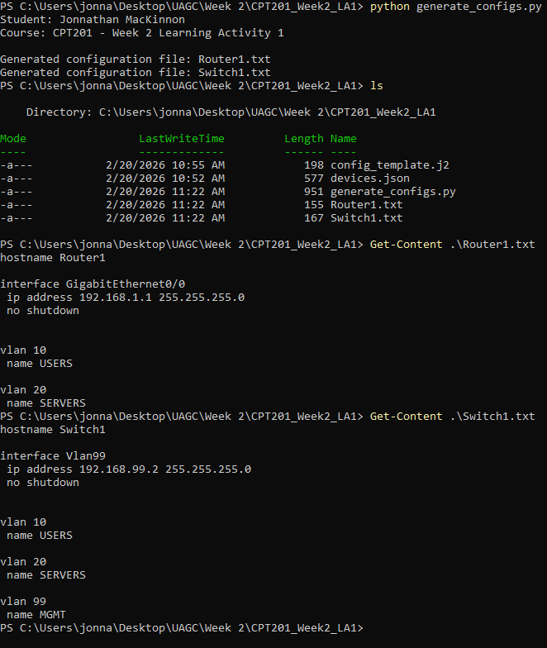

Configuration Files:
Router1:
hostname Router1
interface GigabitEthernet0/0
ip address 192.168.1.1 255.255.255.0
no shutdown
vlan 10
name USERS
vlan 20
name SERVERS
Switch1:
hostname Switch1
interface Vlan99
ip address 192.168.99.2 255.255.255.0
no shutdown
vlan 10
name USERS
vlan 20
name SERVERS
vlan 99
name MGMT
Reflection:
This week helped me see how automation makes cybersecurity tasks more manageable and consistent. Before this lab, I thought configuration and log reviews were all manually done. But using Jinja2 templates opened my eyes on how separating the structure of a configuration from the device specific details makes everything cleaner. Instead of rewriting the same commands for every router or switch, I could reuse a template and just change the variables in a JSON file. That reduces simple mistakes like wrong IP addresses or missing VLAN entries, which could cause real network problems. It also helps enforce a consistent configuration baseline across devices, which improves overall security.
On the log analysis side, writing scripts to filter security events made me realize how quickly automation can highlight suspicious behavior. Instead of scrolling through logs manually, a script can pull failed login attempts or privilege-related events almost instantly. That makes it easier to detect brute-force activity or potential insider misuse. Overall, automation saves time, improves accuracy, and strengthens security monitoring.

